Title
(16pt, Times New Roman, 20mm from top, Upper, Bold, Centered)

Ma Ma⁽¹⁾, Ko Ko⁽²⁾
⁽¹⁾Technological University (Lashio), Myanmar
⁽²⁾Mandalay Technological University, Myanmar

Email: mama@tulashio.edu.mm
(11pt, Times New Roman, Bold, Centered, Maximum-6 pages)

ABSTRACT: This paper presents the ……
(10pt, Times New Roman, and less than 200 words, line spacing is 12pt (used for all content in paper), indentation for the first line is 0.25”)

KeyWORDS: consolidation settlement, embankment, industrial area, ….
(10pt, Times New Roman, and not more than 6 words)
1. INTRODUCTION (10pt, Upper, Bold with chapter number)
The chapter number may be introduced if the authors prefer it. The references are cited as follows:
- Mya Mya (1996)
- Ko Ko (2015)
- Higashiyama, et al. (2019)
…………………………………………………………………………………………………………………………………………………………………………………

2. THEORETICAL BACKGROUND
2.1 Specification of ……(10pt, Bold)
………………………………………………………………………………………………………………………………………………………………………….………..
2.2 Design of … (10pt, Bold)
…………
K_{yoto} + T_{singhua}= S_{uccess} (1)
…………………
2.3 Results of … (10pt, Bold)
…………………………………………………………………………………………………………………………………………………………………………..
3. EXPERIMENT
3.1 Experiment apparatus(10pt, Bold)
…………………………………………………………………………………………………………………………………………………………………………………
3.2 Data(10pt, Bold, Italic)
……………………………………………………………………………………………………………………
……………………………………………………………

Table 1. ………………..
………………………………………………………………………….
4. ANALYSIS
………………………………………………………
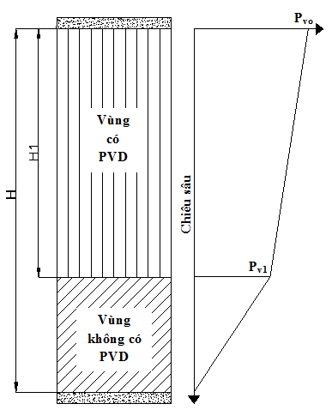
Fig 1.……………………….
…………………………………………………………………………………………………………………………
4. CONCLUSIONS
…………………………………………………………………………………………………………………………………………………………………………………

ACKNOWLEDGEMENT
…………………………………………………………………………………………………………………………………………………………………………………

REFERENCES
- M. King, B. Zhu, and S. Tang, “Optimal path planning,” Mobile Robots, vol. 8, no. 2, pp. 520-531, March 2001.
- H. Simpson, Dumb Robots, 3rd ed., Springfield: UOS Press, 2004, pp.6-9.
- M. King and B. Zhu, “Gaming strategies,” in Path Planning to the West, vol. II, S. Tang and M. King, Eds. Xian: Jiaoda Press, 1998, pp. 158-176.
[4] Simpson, et al, “Title of paper goes here if known,” unpublished.

